Courier Management System - Group BM

**Document History**

| **Version Number** | **Date** | **Author/Owner** | **Description of Change** |
| --- | --- | --- | --- |
| 1 | 2/3/2022 | Valli Priya M | Inital RS Document |
| 2 | 2/3/2022 | Valli Priya M | Added Problem Statement |
| 3 | 5/3/2022 | Vaishnavi S | Add EER Diagram |
| 4 | 29/3/2022 | Vaishnavi S | Added Use Case Diagram |
| 5 | 2/4/2022 | Vaishnavi S | Updated ER Diagram Based On Feedback From Team |
| 6 | 22/4/2022 | Vedant S | Updated RS Document To Match Specified Format |
| 7 | 23/4/2022 | Vedant S | Updated RS Document To Add SQL Queries, Procedures, Updated Problem Statement, Updated ER Diagram and Relational Model |
| 8 | 26/4/2022 | Varenya Varshney | Added Demo Document; Object Model Diagram; Final Review |

# Team Members and their Responsibilities

| **BITS ID** | **Team Members** | **Responsibility** |
| --- | --- | --- |
| 2021MT13019 | VARENYA VASRHNEY | Problem Statement, Requirement Documentation, Relational Schema , Java Application development, SQL Queries, Stored Procedures |
| 2021MT93254 | VALLI PRIYA M | Initial RS Document |
| 2021MT13185 | VAISHNAVI S | Entity-Relationship Model, Use Case Diagram, Stored Procedure |
| 2021MT93065 | Vedant Shetty | Requirement Documentation, RS Document, Frontend Application |
| 2021HT66007 | Velidi Rahul | Relational Schema |
| 2021MT13057 | Varun Mediratta |  |
| 2021MT13083 | Varsha Basavaraj | Relational Schema |
| 2021MT93061 | Veera Rajesh Kommoju |  |

# Problem Statement & Requirements Definition

## Courier Management System

We have decided to create a database for a courier delivery company such as Delhivery or Blue Dart. Customers are billed by a rate card.

The purpose of the database is to manage the complete lifecycle of a courier shipments, track its history and store the rate card to calculate delivery costs within the application.

Customer gets a quote by entering source pincode, destination pincode, shipment dimensions (length, width, height and weight). He likes the quote and goes to the nearest agency to book his shipment. Agent verifies the route and price details, receives booking amount from the customer and books the shipment. He shares the receipt with the customer which has consignment number in it which can be used for all tracking purposes. Shipments from across all the agencies are moved to the local branches at regular interval. Shipments can also arrive at an intermediate branch which falls in the pre-determined route between a given source and a destination pincode. Employee at a branch receives the shipment and based upon the route, he either forwards it to another branch via one of the transportation media viz. Air, Railway, Road or if it is the home branch of the destination address, then he forwards it into the bucket of delivery agents. Agents at every branch timely check their buckets for any fresh or undelivered shipments. Agent picks the shipment from his bucket and attempts its delivery at the destination address. Finally, a shipment either gets delivered or left undelivered. Agent updates the final status of the shipment along with optional remarks.

### Assumptions

* Distance between any two pincodes is generated randomly.
* Route between any two pincodes is generated randomly.
* To calculate the booking amount, a rate card is chosen which looks like this:

|  |  |  |
| --- | --- | --- |
| **Rate Card** | | |
| **Distance** | **Base Rate** | **Extra Weight Factor** |
| 0 - 50Km | 50 | ₹ 10 every 1KG |
| 51-100Km | 100 | ₹ 10 every 1KG |
| 101-500Km | 150 | ₹ 10 every 1KG |
| >500 Km | 200 | ₹ 20 every 1KG |

Metric Shipping Factor (MSF) = 5000 cm3/kg; DIM Weight = Package Volume/MSF; Weight = Max (Actual Weight, DIM Weight)

## Use Case Diagram

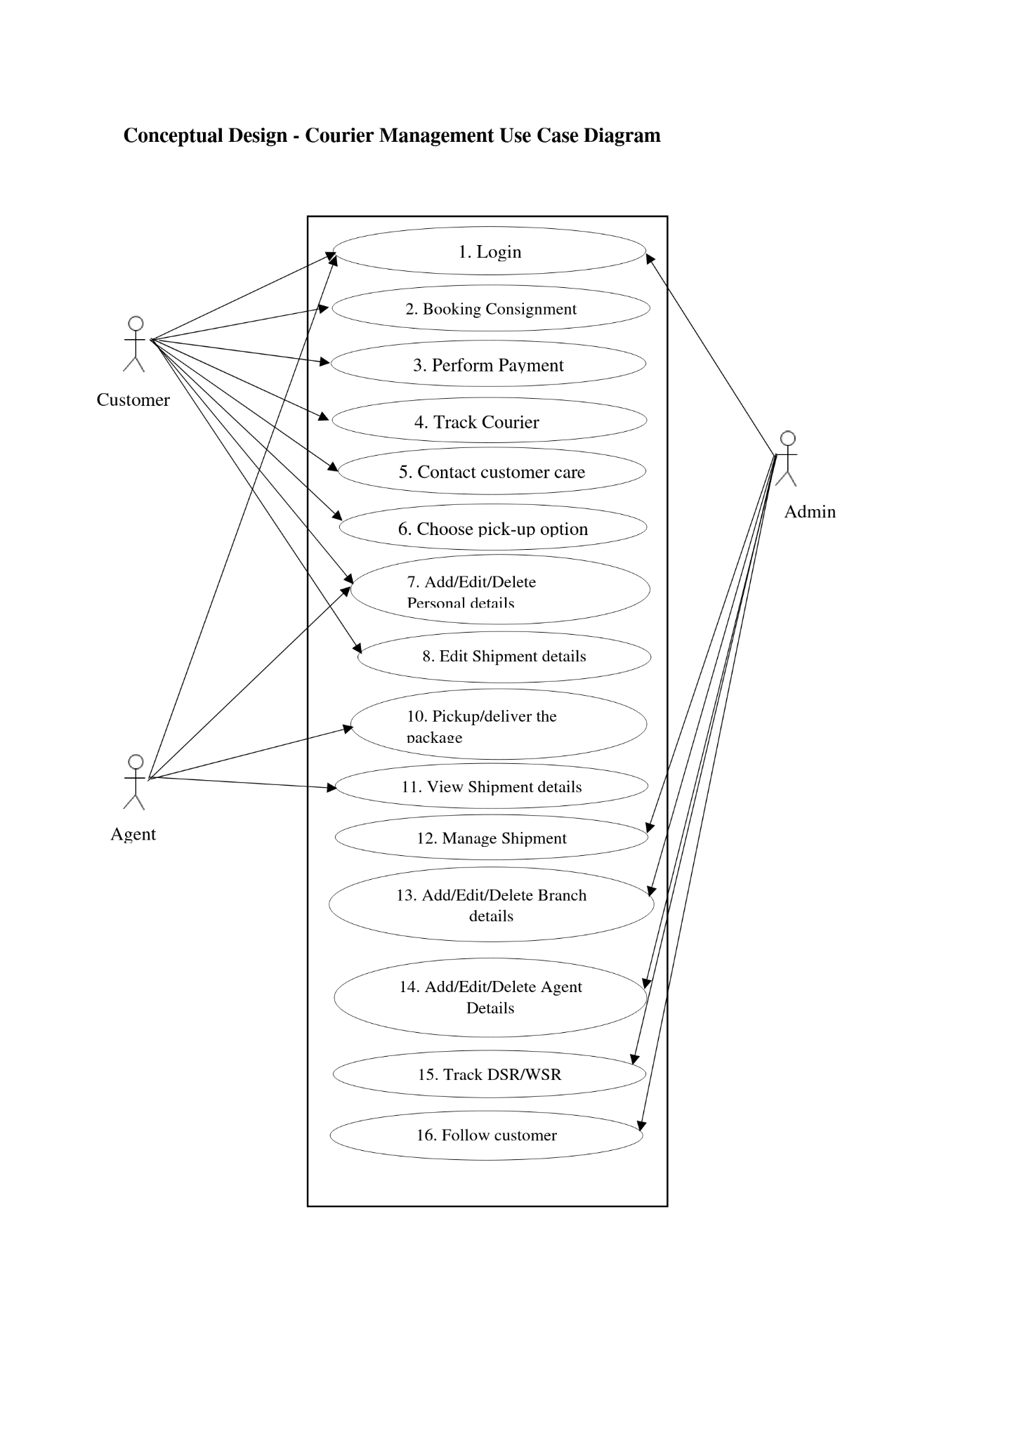

# Entity Relationship (EER Model)

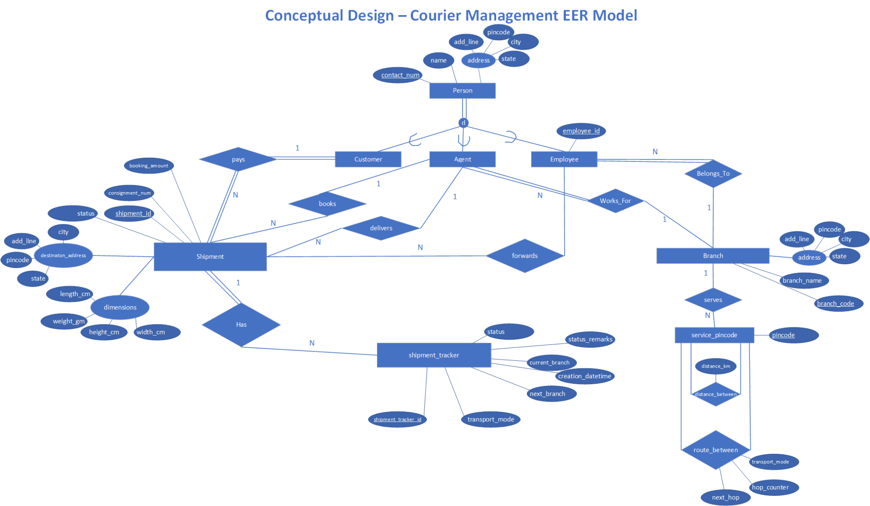

# Object Model Diagram

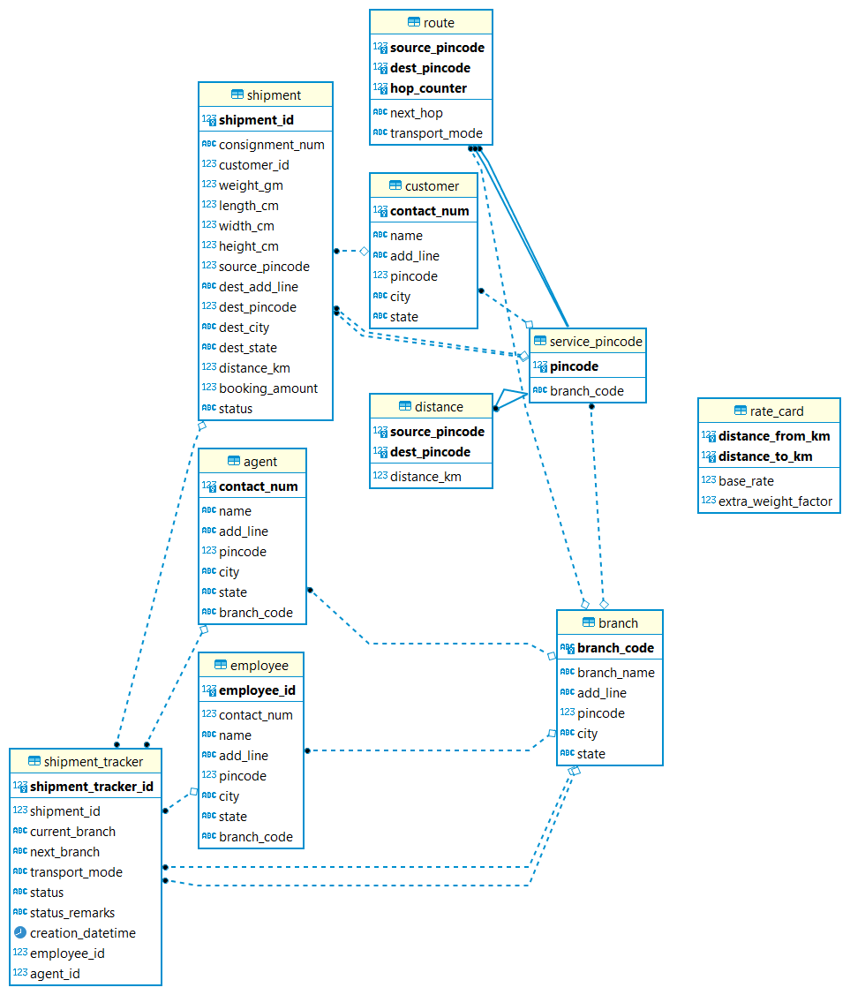

# Relational Database Schema

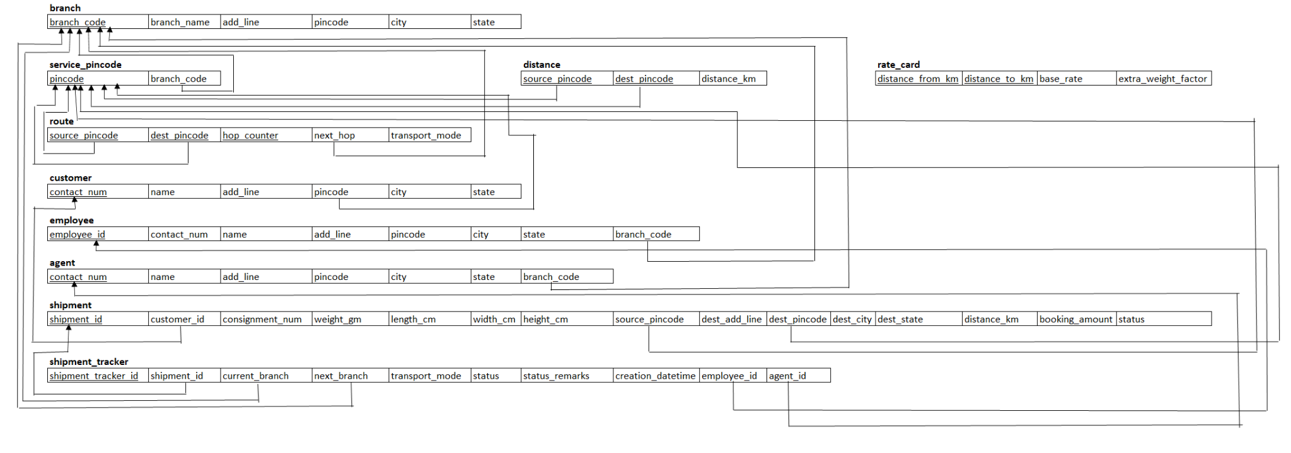

# Normalization

|  |  |
| --- | --- |
| Table Name | branch, service_pincode, distance, route, customer, agent, employee, agent, shipment, shipment_tracker, rate_card |
| State | 3NF |
| Reason | No multivalued attributes, No partial dependencies, No transitive dependency |

# Table Definitions and Data Contents

## Table Definitions

[Table Definitions are listed under SQL Statements >> DDL Statements ]

## Data Contents

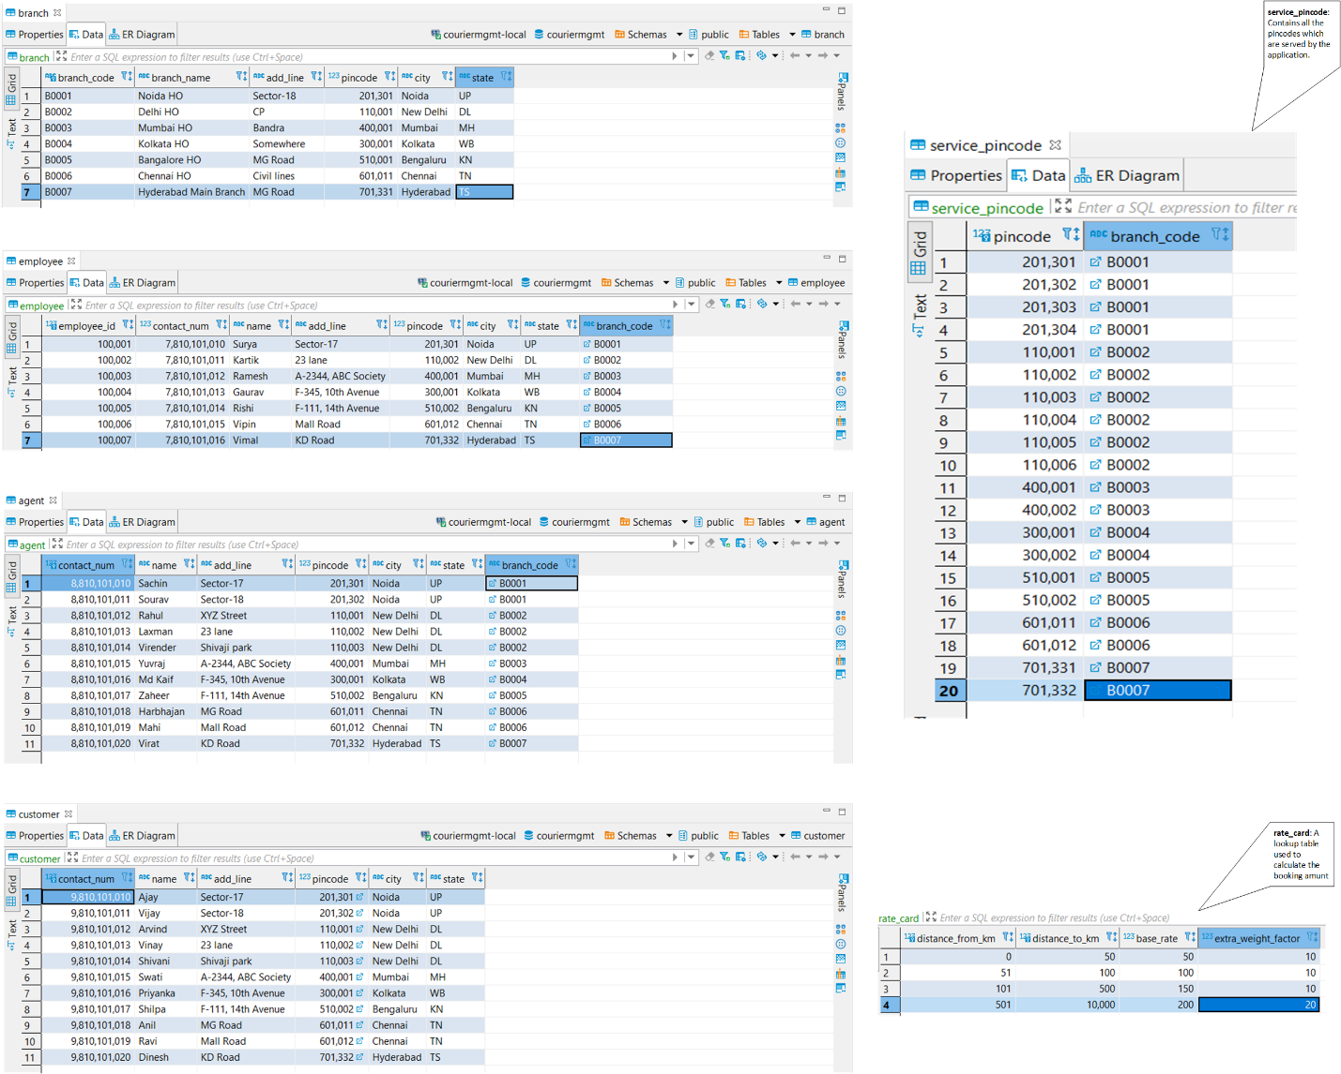

**This data is pre-loaded before the application starts-up using below Insert Queries:**

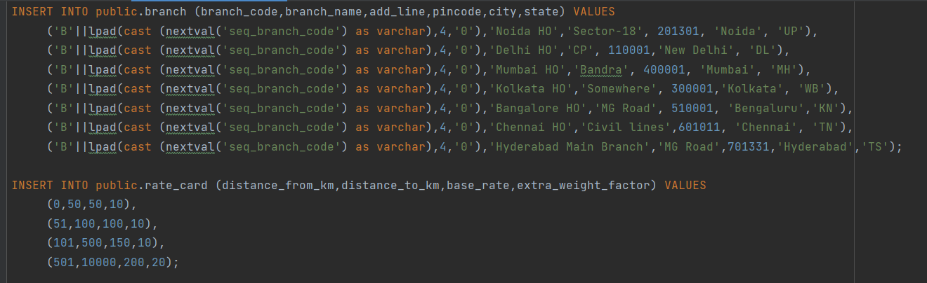

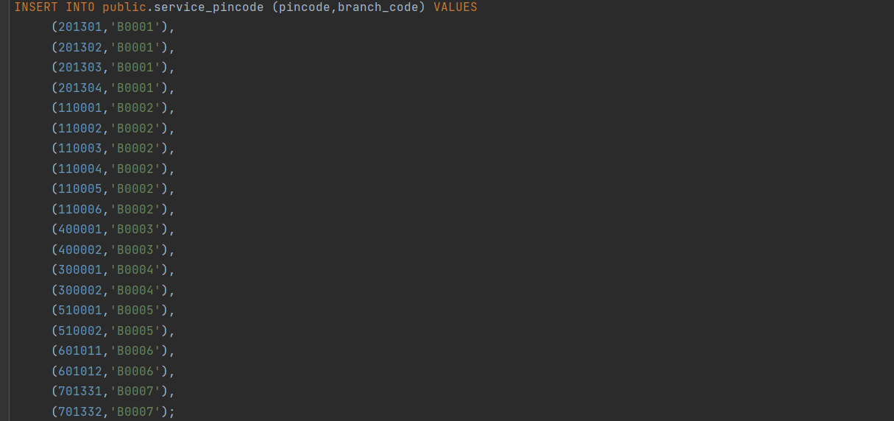

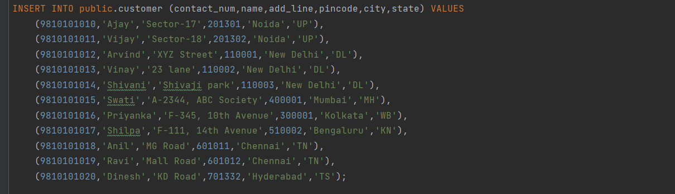

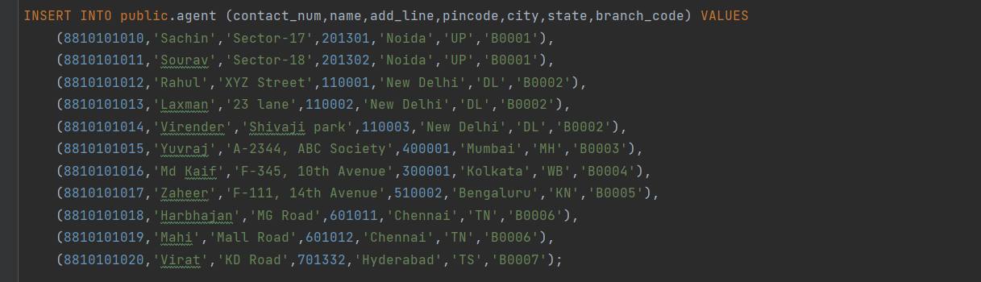

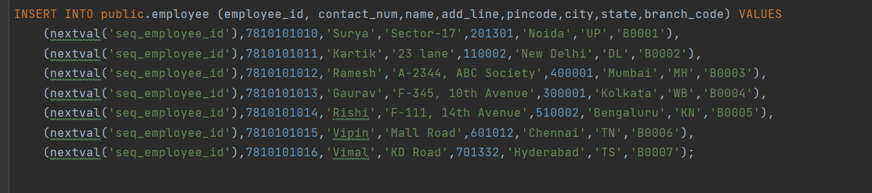

# SQL Statements

## DDL Statements

### Enums

|  |
| --- |
|  |

### Branch

|  |
| --- |
|  |

### Route

|  |
| --- |
|  |

### Actors

|  |
| --- |
|  |

|  |
| --- |
|  |

### Shipment

|  |
| --- |
|  |

|  |
| --- |
|  |

|  |
| --- |
|  |

## DML Statements

Depending upon the use-cases, this application includes various DML SQL Statements for manipulating application data. These SQLs are called from the Java REST APIs which is discussed in detail under User Interface section.

### Branch

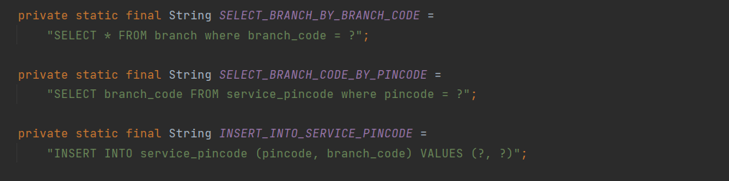

### Route

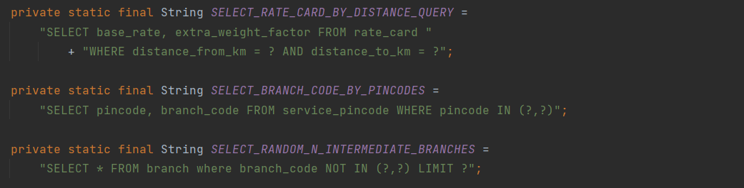

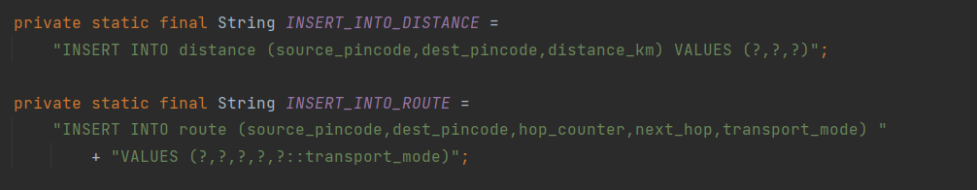

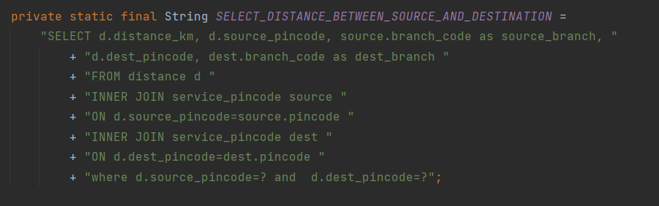

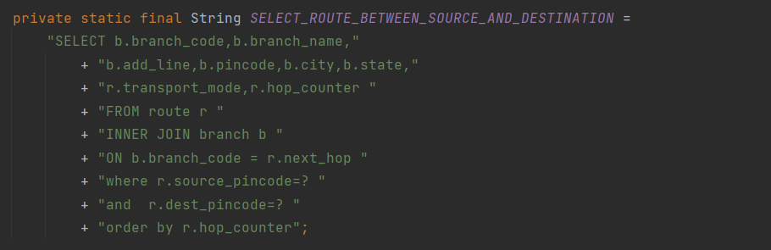

### Actors

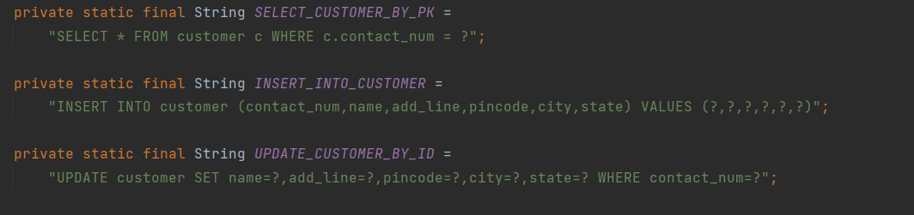





### Shipment

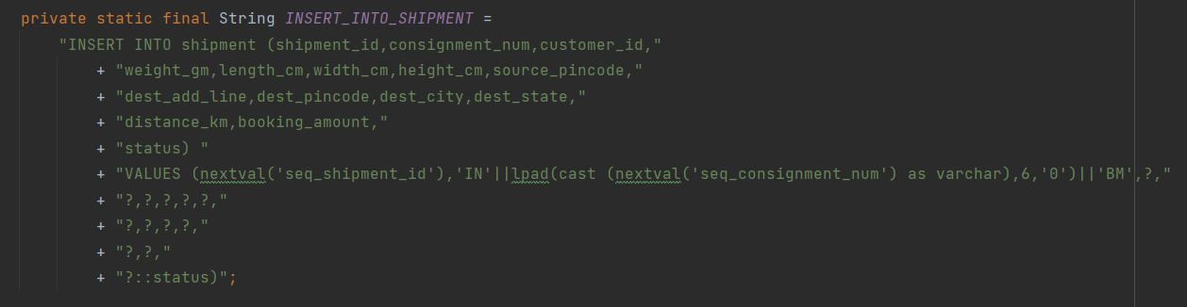

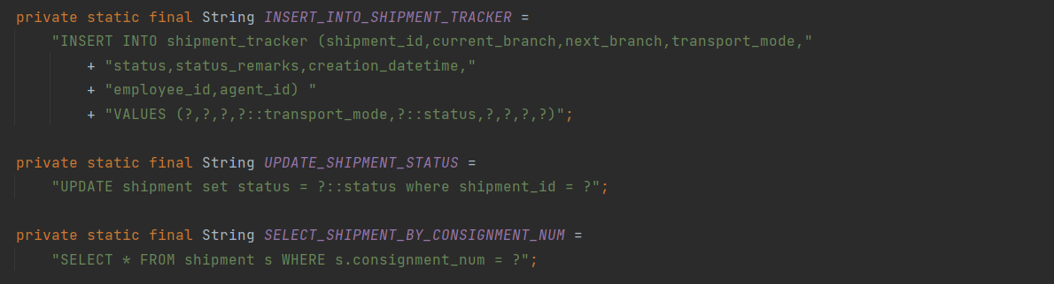

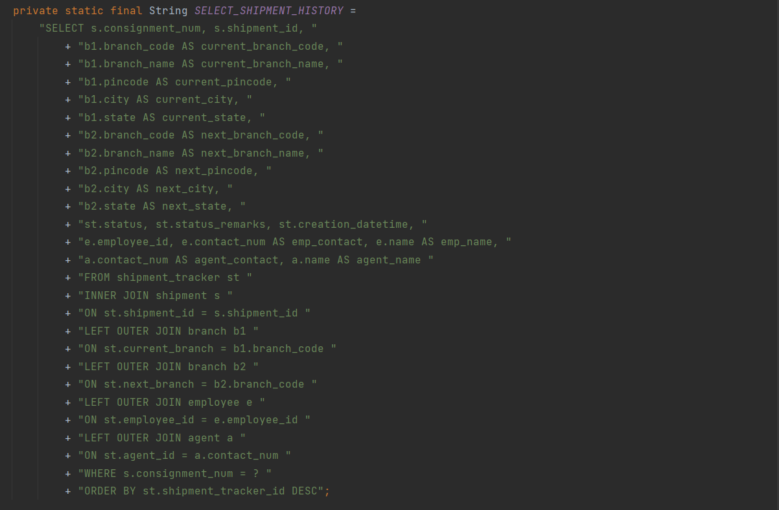

# Stored Procedures/ Triggers

## Procedure to Insert or Update Branch

|  |
| --- |
| create or replace  procedure upsert_branch  (  p_error inout VARCHAR,  p_is_insert in BOOLEAN,  p_branch_code inout branch.branch_code%type,  p_branch_name in branch.branch_name%type,  p_add_line in branch.add_line%type,  p_pincode in branch.pincode%type,  p_city in branch.city%type,  p_state in branch.state%type  )  language plpgsql  as  $$  declare  -- No variable declarations at this time.  begin  if p_is_insert  then  p_branch_code = 'B' || lpad(cast (nextval('seq_branch_code') as varchar), 4, '0');  insert  into  branch  (  branch_code,  branch_name,  add_line,  pincode,  city,  state  )  values (  p_branch_code,  p_branch_name,  p_add_line,  p_pincode,  p_city,  upper(p_state));  insert into service_pincode (pincode, branch_code) values (p_pincode,p_branch_code);  else  update  branch  set  branch_name = p_branch_name,  add_line = p_add_line,  pincode = p_pincode,  city = p_city,  state = upper(p_state)  where  branch_code = p_branch_code;  update service_pincode set pincode = p_pincode where branch_code = p_branch_code;  end if;  exception  when others then  p_error := sqlerrm;  end  $$; |

## Procedure to Insert Or Update Agent

|  |
| --- |
| create or replace  procedure upsert_agent  (  p_error inout VARCHAR,  p_is_insert in BOOLEAN,  p_contact_num in agent.contact_num%type,  p_name in agent.name%type,  p_branch_code in agent.branch_code%type,  p_add_line in agent.add_line%type,  p_pincode in agent.pincode%type,  p_city in agent.city%type,  p_state in agent.state%type  )  language plpgsql  as  $$  declare  -- No variable declarations at this time.  begin  if p_is_insert  then  insert  into  agent  (  contact_num,  name,  branch_code,  add_line,  pincode,  city,  state  )  values (  p_contact_num,  p_name,  p_branch_code,  p_add_line,  p_pincode,  p_city,  upper(p_state));  else  update  agent  set  branch_code = p_branch_code,  name = p_name,  add_line = p_add_line,  pincode = p_pincode,  city = p_city,  state = upper(p_state)  where  contact_num = p_contact_num;  end if;  exception  when others then  p_error := sqlerrm;  end  $$; |

## Procedure to Insert Or Update Employee

|  |
| --- |
| create or replace  procedure upsert_employee  (  p_error inout VARCHAR,  p_is_insert in BOOLEAN,  p_employee_id inout employee.employee_id%type,  p_contact_num in employee.contact_num%type,  p_name in employee.name%type,  p_branch_code in employee.branch_code%type,  p_add_line in employee.add_line%type,  p_pincode in employee.pincode%type,  p_city in employee.city%type,  p_state in employee.state%type  )  language plpgsql  as  $$  declare  -- No variable declarations at this time.  begin  if p_is_insert  then  p_employee_id = nextval('seq_employee_id');  insert  into  employee  (  employee_id,  contact_num,  name,  branch_code,  add_line,  pincode,  city,  state  )  values (  p_employee_id,  p_contact_num,  p_name,  p_branch_code,  p_add_line,  p_pincode,  p_city,  upper(p_state));  else  update  employee  set  contact_num = p_contact_num,  branch_code = p_branch_code,  name = p_name,  add_line = p_add_line,  pincode = p_pincode,  city = p_city,  state = upper(p_state)  where  employee_id = p_employee_id;  end if;  exception  when others then  p_error := sqlerrm;  end  $$; |

# User Interface and Database connectivity

Project is designed and implemented as a web application which exposes the functionalities into set of different RESTful APIs. These APIs are built using Java/Spring MVC framework. User Interface to access these APIs is a simple OpenAPI REST client. Using this rest client, users can build and execute the HTTP request which internally accesses the database and then return an HTTP response.

UI is well-documented so that any user can easily access these APIs and get the desired response.

## Database Connectivity

Since it is a Java/Spring application, Spring JDBC is used to setup the database connectivity.

### DB Connection Details

Using these connection details, JdbcTemplate bean is instantiated which holds the DB session. This template is then used to execute SQL statements.

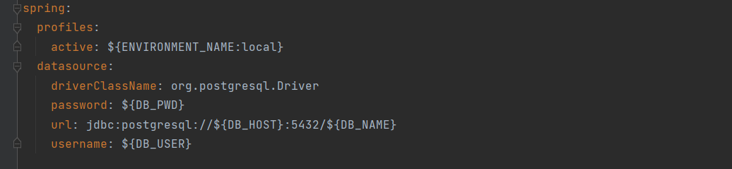

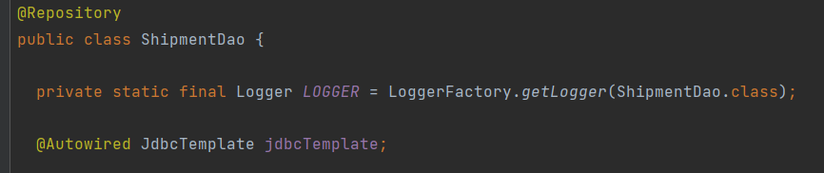

### SQL Read Operations

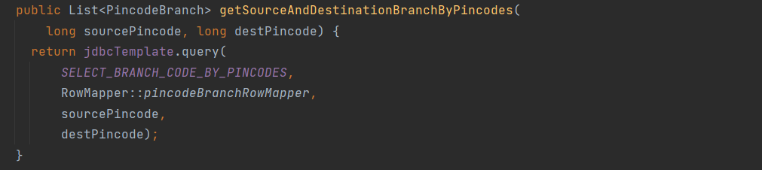

### SQL Write Operations | Transactions

**@Transactional** annotation makes sure that any DB operation wrapped inside it will be considered as an atomic operation. If any runtime exception is thrown during the execution of the code lying within @Transactional boundary then the changes will be rolled back to the previous consistent state otherwise the changes will be committed to the DB.

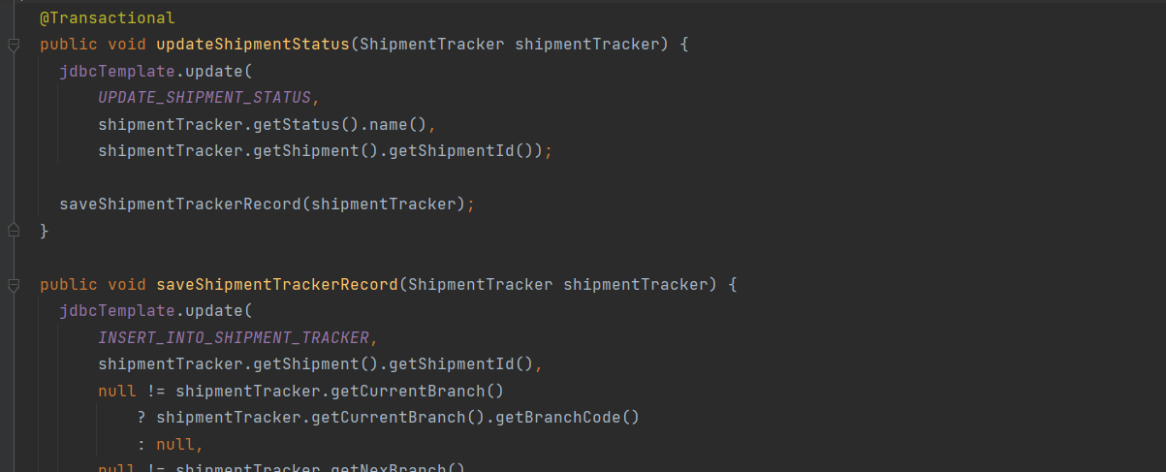

### Call Stored Procedure

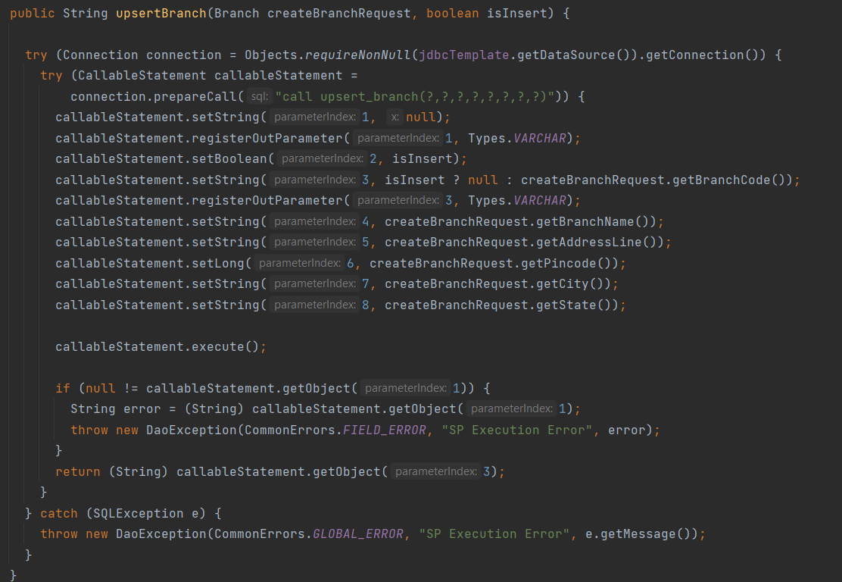

## Application Demo | User Interface

Attached is the Demo Documentation which showcases the overall flow of this courier management application.



# Reference

For complete code including SQLs and documentation, please refer to the following links:

* GitHub repository:
  + <https://github.com/varenyavv/courier-mgmt-group-bm>
* DB Scripts:
  + <https://github.com/varenyavv/courier-mgmt-group-bm/tree/main/src/main/resources/db/migration>
* Documentation:
  + <https://github.com/varenyavv/courier-mgmt-group-bm/tree/main/Documentation/Final>